BIOLOGY DEPT
NAMUNGOONA SALAF S.SCH
OSMOSIS TEST,

SECTION B
1.In an experiment , slices of onions epidermis were placed in sucrose solution of different concentrations .The percentage of plasmolysed cells were determined after 30minutes .the results were recorded in the table below
Concentration of sucrose (M) | 0.55 | O.6 | O.65 | 0.7 | 0.75
Percentage of plasmolysed cells | 0 | 5 | 20 | 80 | 100

a) using a graph paper , represent the above results graphically(8½mrks)


bi) What is meant by plasmolysis (02mrks)
................................................................................................................................
................................................................................................................................
ii)What causes plasmolysis? (01mrk)
................................................................................................................................
................................................................................................................................
c) Explain the results of 0.55 molar sucrose (03mrks)
................................................................................................................................
................................................................................................................................
................................................................................................................................
................................................................................................................................
d) From your graph describe the relationship between molar concentration of sucrose solution and percentage of plasmolysed cells(02mrks)
................................................................................................................................
................................................................................................................................
................................................................................................................................
................................................................................................................................
e) What term would be used on a plant where 100% of its cells are plasmolysed (01mrk)
................................................................................................................................
................................................................................................................................
f) In which ways is the process that has led to plasmolysis, important to plants(03mrks)
................................................................................................................................
................................................................................................................................
................................................................................................................................
................................................................................................................................
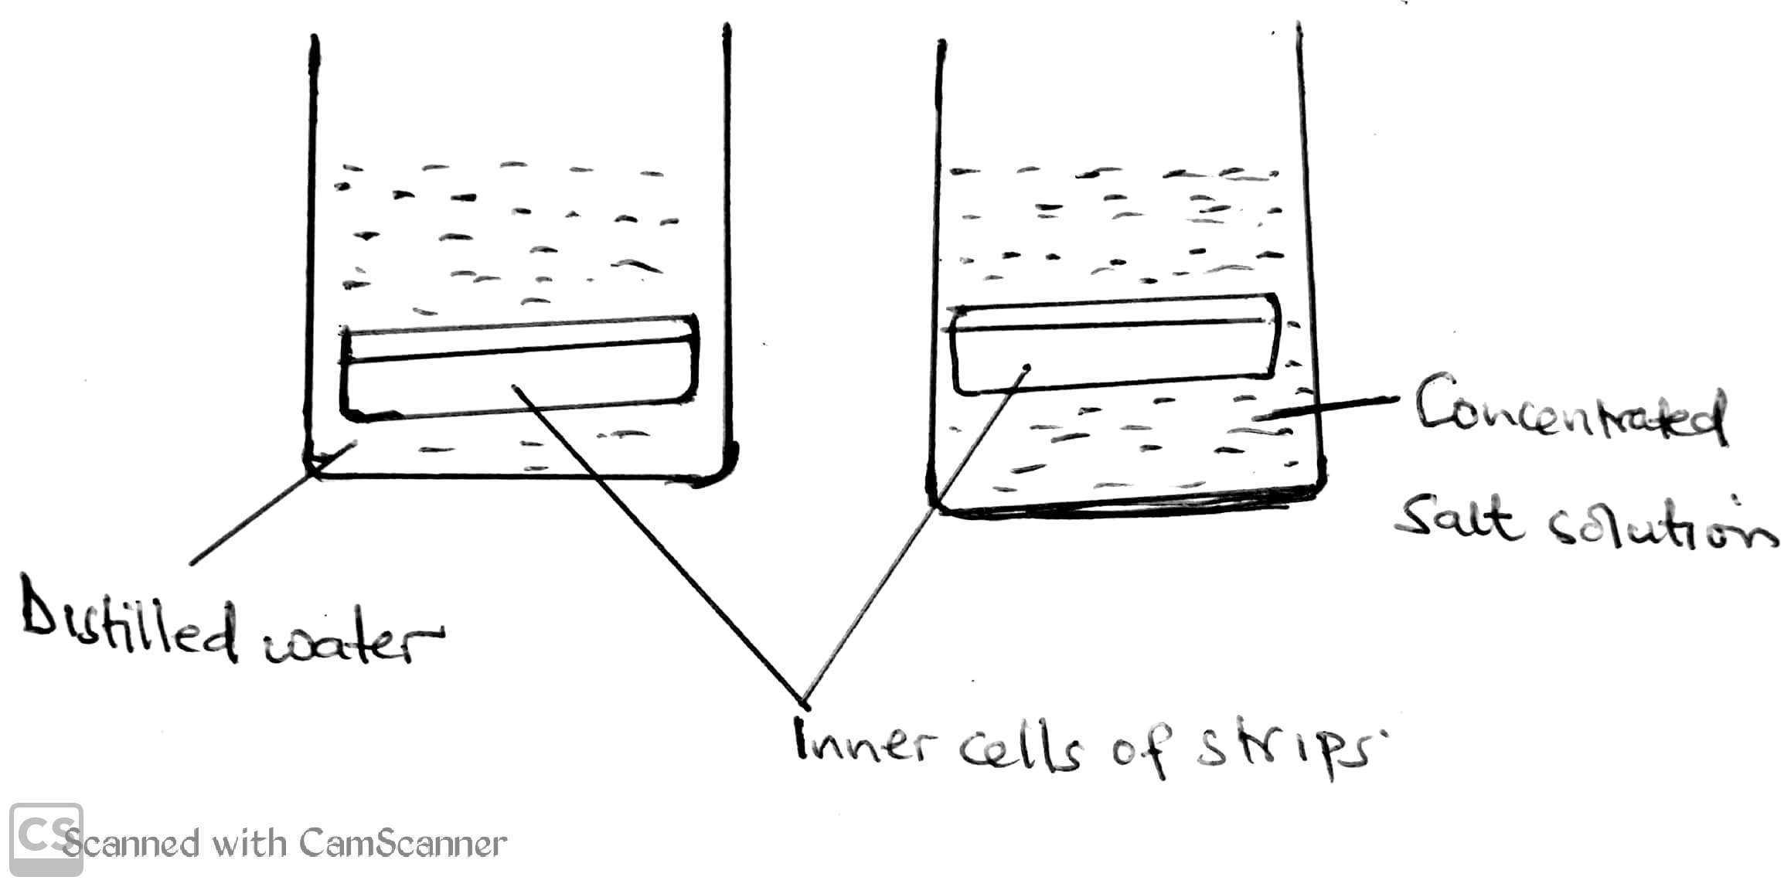
2. In an experiment to determine to determine a biological process, fresh pawpaw leaf stalk was cut longitudinally into two halves to expose the inner cells (Cortical cells). One strip was placed in a beaker containing a concentrated salt solution and the other in distilled water. The experiment was left to stand for 22minutes

.
a) State the biological process being demonstrated
................................................................................................................................
................................................................................................................................
b) State and explain what will be observed to the strips after the experiment
i) Strip from concentrated salt solution (03mrks)
................................................................................................................................
................................................................................................................................
................................................................................................................................
................................................................................................................................
ii) strip from distilled water (03mrks)
................................................................................................................................
................................................................................................................................
................................................................................................................................
................................................................................................................................
c) State and explain any one precaution to be considered while setting this experiment(02mrks)
................................................................................................................................
................................................................................................................................
d) in the space. Sketch a graph to show how the mass of the strip placed in distilled water changed with time of the experiment
................................................................................................................................
................................................................................................................................
................................................................................................................................
................................................................................................................................
3a). Distinguish between plasmolysis and crenation (02mrks)
................................................................................................................................
................................................................................................................................
................................................................................................................................
................................................................................................................................
b) Explain the following observations
i) When meat is sprinkled with salt takes a longer time to go bad (03mrks)
................................................................................................................................
................................................................................................................................
................................................................................................................................
................................................................................................................................
ii) Its not advised to pour salt on wound(02mrks)
................................................................................................................................
................................................................................................................................
..........................................................................................................................
ii) What happens to a red blood cell when placed in distilled water (03mrks)
Section C
4. Describe an experiment to show that osmosis takes place in a living cell

Good luck , 08th june 2020
Stay safe,keep home
Avoid crowded areas and always put on a protective mask incase your moving

